**INSY 5373 / OPMA 5364**

Instructor: Rama Koganti

Fall 2023

**KMR Consultants Inc.**

**Speakeasy Project**

**Group 9**

Myalinda Martinez UTA ID: 1000412076

Raghul Shanmuga Sundaram UTA ID:1002075339

We, Myalinda Martinez, and Raghul Shanmuga Sundaram did not give or receive any assistance on this project, and the report submitted is wholly our own.

**TABLE OF CONTENTS**

**Project Schedule**

**1.DEFINE/Initiation PHASE (August 31-September 11, 2023)**  
 1.1 INTRODUCTIOn

1.2 PROBLEM IDENTIFICATION

1.3 WBS

1.4 Communication Plan

1.5 Responsibility Matrix

**2.Planning PHASE (September 12-October 19)**

2.1 cost analysis  
2.2 Cost-benefit analysis  
2.3 NPV Calculation

2.4 Gant Chart

**3.Execution PHASE (october 19-December 14)**

3.1 Renovations, software

3.2 Marketing and Promotion

3.3 FUTURE EXPANSION

3.4 RISK ANALYSIS

**4.Closing PHASE (December 15-January 25,2024)**

4.1 Testing and training

4.2 LESSON LEARNED

4.3 Closing Checklist

**1.Defing Phase**

**1.1 Introduction**

Group 9 project management team chose the real estate and construction industry to bring a new business into a growing city under the business name KMR Consultants which would establish a new speakeasy style bar. A speakeasy is a covert or secret business that existed in the United States during the Prohibition era, which lasted from 1920 to 1933. The concept of a speakeasy is rooted in the past, and in today's generation, it is fun and unique outlet to experience. The project goal is to bring a new bar lounge to satisfy local residents need for increased entertainment in hopes of connecting people to the Arlington, Texas area while they build their lives and reducing the need to travel to Dallas or Fort Worth. Small cities in a larger metroplex area such as Dallas Forth Worth gain the benefits of their cities growing with residents staying to live and work but many smaller cities do not provide entertainment for those staying. People are commuting to work in Dallas and Fort worth and having to do commute again in search of entertainment that is not being offered yet in Arlington, TX.

KMR Consultant’s objective is to enrich the overall Arlington, TX experience and address the longstanding absence of an alternative club venue in the downtown Arlington area which could provide relaxation, socialization, and responsible enjoyment of quality beverages. In addition to offering a welcoming and secure location for all to unwind, this speakeasy will also build a special feeling of community, give a unique social outlet, and benefit the local economy. As a result, establishing a local speakeasy is an important step in raising the general satisfaction and well-being of Arlington’s diverse community.

There are almost 400,000 residents in Arlington, TX alone and there has been a steady increase in city population year over year of about 2% and an increase of the age groups between 20-39. With more young professionals staying in the area, Arlington has prime real estate that can be transformed to provide a new speakeasy lounge, which is a growing trend for young professionals and local residents to enjoy.

**1.2 Problem Identification**

There is an undeniable need to establish more unique entertainment in close proximity to local universities that have large diverse populations. The steady incline of the 20-29 age group staying in the same areas they graduate with their undergrad degrees leaves a gap in providing entertainment services. Which makes this the target market for a speakeasy that caters to a younger generation. There are also not many places close to the university and in downtown Arlington that cater to a young audience interest in entertainment and socializing. The retro charm and mystery of a speakeasy theme make it a standout selling feature that can draw in a passionate and inquisitive clientele.

**1.3 Work Breakdown Structure**

**1.4 Communication Plan**

**1.5 Responsibility Matrix**

**2.Planning Phase  
  
2.1 Cost Analysis**

**2.2 Cost- Benefit Analysis**

|  |  |  |  |  |  |  |
| --- | --- | --- | --- | --- | --- | --- |
| **Cost Benefit Analysis** | | | | | | |
| **COSTS** | **YEAR1** | **YEAR2** | **YEAR3** | **YEAR4** | **YEAR5** | **YEAR6** |
| **people cost** | $134,500.00 | $137,190.00 | $139,933.80 | $142,732.48 | $145,587.13 | $148,498.87 |
| **systems cost** | $5,550.00 | $5,550.00 | $5,550.00 | $5,550.00 | $5,550.00 | $5,550.00 |
| **Utilities +rent** | $29,000.00 | $29,000.00 | $29,000.00 | $29,000.00 | $29,000.00 | $29,000.00 |
| **replacement costs** |  |  | $6,000.00 |  |  | $6,000.00 |
| **total** | $169,050.00 | $171,740.00 | $180,483.80 | $177,282.48 | $180,137.13 | $189,048.87 |
| **Cumulative** | $169,050.00 | $340,790.00 | $521,273.80 | $698,556.28 | $878,693.40 | $1,067,742.27 |
|  |  |  |  |  |  |  |
| **BENEFIT** | **YEAR1** | **YEAR2** | **YEAR3** | **YEAR4** | **YEAR5** | **YEAR6** |
| **alcohol revenue** | $90,000.00 | $107,100.00 | $127,449.00 | $151,664.31 | $180,480.53 | $214,771.83 |
| **food sales** | $43,200.00 | $46,656.00 | $50,388.48 | $54,419.56 | $58,773.12 | $63,474.97 |
| **total** | $133,200.00 | $153,756.00 | $177,837.48 | $206,083.87 | $239,253.65 | $278,246.80 |
| **Cumulative** | $133,200.00 | $286,956.00 | $464,793.48 | $670,877.35 | $910,131.00 | $1,188,377.80 |

**2.3 NPV Calculation**

To calculate the Net Present Value (NPV) for Speakeasy with the provided cash flow data and an initial setup cost of $130,100, we can use the NPV formula.





NPV ≈ $59235.42

Therefore, the Net Present Value (NPV) of the Speakeasy, considering the provided cash flow data and an initial setup cost of $130,100 with a discount rate of 10%, is approximately $59,235.42.  
**2.4 Gant Chart**

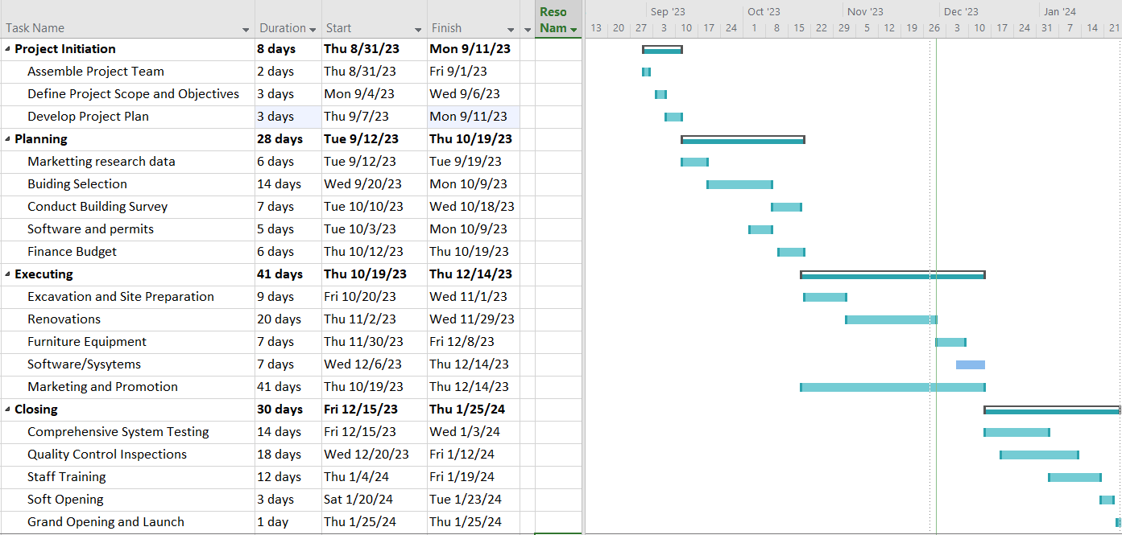

**3.Execution phase**

3.1 RENOVATIONS, SOFTWARE  
  
KMR Consultant team chose an already established building to help with using sustainability practices and not having to bid on land surrounding the university or downtown Arlington area. We reached out to several real estate companies in the downtown Arlington area and found that a few buildings had limitations in regard to only being office space only. There is a waitlist for properties in the highly marketable area along Abrams Street. We are partnered with Warner Alan Properties / Waste Advantage Partners on leasing retail space for one of those buildings. Building consists of no grease traps to install or a functioning kitchen. Lease rent amount is going for $2,400 a month and is 1200 square feet. Reached out to several local interior designs places and targeted those that specialize in sustainability practices. ARCHIPHY Architecture and Interiors charges $12 a square foot for basic renovations. They provide Mechanical Electrical and Plumbing engineering on the space to establish our full services of running the bar and providing electricity and restrooms to patrons. Excavation of site will begin on October 20 and the process will start to prepare the site and gutting the inside for the interior design team to come. Software purchased is Homebase for our employment and payroll system, Square Point of Sales to handle sale transactions and ADT Business Security Systems.

**3.2 MARKETING**

Marketing and Promotion will begin as renovation are underway for the interior of the building. We are using a strong social media presence with Instagram, Tik Tok and Snapchat with digital ads and partnering with local influencers. Small portion will be allocated to print ads in targeted local newspapers, such as university student newspapers.

**3.3 FUTURE EXPANSION**

Future expansion will be new project teams to establish speakeasy in Carrollton, Grand Prairie and Richardson, Texas area. We will introduce themed nights to boost our revenue streams which will focus on major holidays, comedy nights, and live dance performances. We will offer mixology classes with our bartenders as an additional income for them and for future hiring pool. We will establish a partnership with Amore Mio Italian restaurant, close to new speakeasy for an additional revenue to provide food to patrons. We are allocating 6% of sales from food. Establish community connections and become involved in local arts festivals and block parties. We will sell merchandise to help brand and advertise the business with creative slogans and will help to be an additional revenue stream.

**3.4 RISK ANALYSIS**

**4.Closing Phase**

4.1 TESTING, TRAINING AND LESSONS LEARNED

We will be hiring two part-time bartenders that will work 32 hours a week and starting salary will be $27,000 base that company provides. There will be two servers that will work 25 hours a week and starting salary will be $25,000 base. These do not include tips from customers which bartenders and servers can keep directly. There will be one part-time security guard with base salary of $23,000. This will adjust depending on hours needed service. We will have a three-piece jazz band that will perform for special events and have allocated $6,000 for first year to play at special events only. Music on most weekends will run through a sound system and curated playlists. Training of all staff will happen over two weeks and will consist of training on the Homebase system they will use for payroll and scheduling, Square Point of Sales which will be used for drink and food sales, security system, sound system, password protocols and knowing menu selections of the specialty drinks provided. Bartenders will have solo training on alcohol beverages, tricks and protocols to follow at bar with patrons. All training will be documented in the Homebase system and stored on a digital file company owned computer as back-up.

Last two weeks will have quality checks and testing of all equipment and systems. There will be a soft opening with limited family and friends to help have a run through of the systems and with staff working together. Once final testing and updates are made after the soft opening, then a grand opening will be schedule in the new year of 2024.

**4.2 LESSONS LEARNED**

Lessons learned is that it is very important to stick to the communication plan and touch base with team and hold team members accountable for their responsibilities and when they do not complete. Vendors have their own schedules and so certain things are out of your control such as the limitations placed on buildings and what can be sold or not. Vendors having difficulty getting parts on time and delivered for installation. Having back-ups for when things break, especially with offering glassware to patrons. It was very important we follow our budget and have an accurate cost analysis so we could understand when we would make a profit. Ideally, we thought we would make a profit much sooner than expected. With future plans to bring in other streams of revenue we could potentially see a positive profit sooner.

**4.2 Closing Checklist**

